Project 2 – School Portfolio

# General Description

* Website for the school portfolio of each student
* **Folder name:** \SchoolPortfolio_YourName\...
* **Due date:** Sunday, December 4th, 2016 (before midnight)

The second project for the Communication Design class consists of creating a website for your portfolio of work at Hsinchu American School starting from 2015. In this project, we will apply all knowledge learned so far in the class, including website design, planning, HTML, and CSS. Students are encouraged to use HTML and CSS features and techniques not yet learned in class in order to improve their website’s layout and usability. Since Unit 3 (CSS) has been complete, students **should not** use tables to organize their website’s layout.

The main purpose of this website is to show the classes the student has taken at HAS in the years 2015-2016 and 2016-2017, as well as some of work done in each class. If the students do not have a record of their work (e.g. images, printouts, documents, etc.), they can describe it and use supporting images (e.g., from Google). An example of the website structure is shown below:

* Home
* Courses
  + 2015-2016
    - Introduction to Writing
    - World History
    - Equilibrium Statistical Physics
    - …
  + 2016-2017
    - AP Chinese
    - AP Chemistry
    - AP Physics
    - …
* About
* Contact

For each course, the website must at least provide the following content:

* Course name
* Teacher name
* Course description
* Examples of major work done in the class

# Requirements

## Website plan (5%)

### (2%) Homepage Sketch

A sketch of the website’s home page must be done via Word, PowerPoint or other software, or hand-drawn on paper. The sketch must show the general layout of the website’s homepage, the navigational links, and main content.

### (2%) Website Structure

A sketch of the website’s navigational structure must be done via Word, PowerPoint or other software, or hand-drawn on paper.

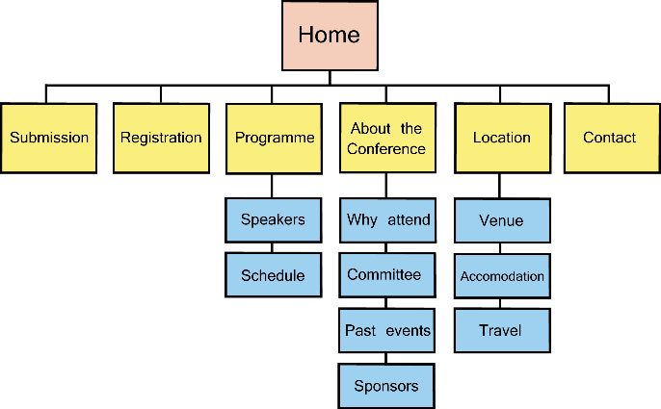

### (1%) Folder Structure

A sketch of the website’s folder structure must be done via Word, PowerPoint or other software, or hand-drawn on paper. You can do a Google image search of “website folder structure”.

## Website content (40%)

### (5%) Images

The website must include at least one image per page. The images must be related to content.

### (25%) Courses

The website must include at least one webpage for each course. Each course must have the course name, teacher name, course description, and examples of work done in class.

### (5%) Navigation Menu

The website must include a main navigational menu which will guide the user around the website. The navigational menu must be included in all pages in the site.

### (5%) CSS

The website must use CSS for styling. No styling should be applied inside the .html files.

## Coding (5%)

Good coding practices must be employed in the website. This includes the following:

* Appropriate indentation (use tab) of all nested elements.
* Opening and closing of all HTML elements (except for empty elements; e.g. <br />).
* Appropriate use of semantic tags (e.g. <main>, <nav>, <article>, etc.).
* Appropriate syntax and indentation of CSS selectors and properties.
* Appropriate use of “class” and “id” for CSS selectors.

## Evaluation Rubric (50%)

The evaluation rubric we created together in class will be used to evaluate your website. When the websites are completed, the teacher and the students will use this rubric to evaluate each website. 40% of the grade in this section will come from the teacher, and 10% from the students.

